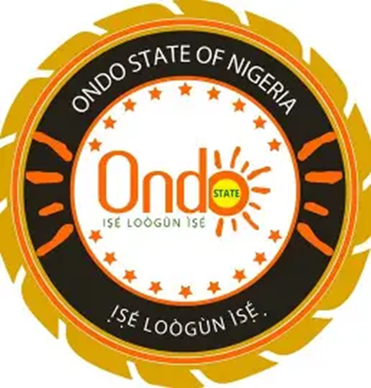

ONDO STATE GOVERNMENT

Business Enabling Environment (BEE) Compliance Report

COMPLIANCE REPORT TEMPLATE
This report presents a comprehensive overview of compliance and service delivery performance for the Month of January, February, March and April 2025 across the 5 key Business Enabling Environment (BEE) agencies in Ondo State. Service requests were duly received and processed in line with published timelines. Strategic measures implemented to strengthen transparency, improve turnaround time, and resolve grievances have yielded positive results, with 80% of requests completed within the stipulated timelines.
1. Total Number of Service Request Received
Service Area | No of Request Received (2025)  JAN FEB MAR APRIL | Channel of Receipt (Online/Offline)
Vehicle Inspection | 6935 6840 6048 5458 | Offline
Survey Plan Process and Procedure | 207 350 383 277 | Offline
Business Premises Permit | 804 800 526 589 | Offline & Online
Environmental Impact Assessment | -  2 2 5 | Offline & Online
Signage Permit Applications | - 2 1 3 | Offline

2. Service Delivery Timeframes: 15 minutes
Service Type | Official SLA | Source Document
Vehicle Inspection | 1 Working Day | https://ondostate.gov.ng/index.php/vehicle-inspection-procedure/
Survey Plan Process and Procedure | 1 Month | https://ondostate.gov.ng/index.php/survey-plan-processes-2023/
Business Premises Permit | 14-45 Working Days | https://ondostate.gov.ng/index.php/business-premises-regulation-and-procedure/
Environmental Impact Assessment | 3 Month | https://ondostate.gov.ng/index.php/ministry-of-environment-processes-and-guideline-for-eia/
Signage Permit Applications | 7 Working Days | https://ondostate.gov.ng/index.php/signage-agency/

Service Type | Resolved within SLA | % Compliance | Resolved Beyond SLA | % Non-Compliance
Vehicle Inspection | 25,281 | 100% | Nil | 0
Survey Plan Process and Procedure | 791 | 65% | 426 | 35%
Business Premises Permit | 2,283 | 84% | 436 | 16%
Environmental Impact Assessment | 6 | 70% | 3 | 30%
Signage Permit Applications | 5 | 80% | 1 | 20%
3. Request for Resolution Metrics

4. The Report Summary
Participating MDA | Service Type | Approved SLAs | No. of Requests Received | No. of Request Completed within SLA | % Total Application Completed within SLA
Ondo Ministry of Transport | Vehicle Inspection | 1 Working Day | 25,281 | 25,281 | 100%
Ondo Ministry of Lands and Housing | Survey Plan Process and Procedure | 1 Month | 1,217 | 791 | 65%
Ministry Of Commerce, Industry & Cooperative Services | Business Premises Permit | 14-45 Working Days | 2,719 | 698 | 84%
Ondo State  Ministry Of Environmental | Environmental Impact Assessment | 3 Month | 9 | 6 | 70%
Ondo State Signage & Advertisement Agency | Signage Permit Applications | 7 Working Days | 6 | 5 | 80%

Observations and Recommendations
Under the State Action on Business Enabling Reforms (SABRE) Program, this report details Ondo State's performance on Disbursement Linked Indicator 5 (DLI 5) for the Months of January, February, March and April. With an average SLA compliance rate of 80% across important business-enabling services, the results show that the State has maintained strong operational capacity. This indicates a significant increase in the overall effectiveness of service delivery.

