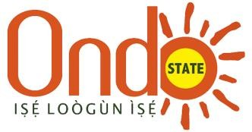
ONDO STATE CofO STATISTICS
Details of Titles Registered in Ondo State
Description/year  (Jan- Sept) | Total number of CofO registered | Number of CofOs digitized and indexed in a digital archive | Number of undigitized CofOs
2012 | 1,476 | - | 1476
2013 | 1,339 | - | 1339
2014 | 1,492 | - | 1492
2015 | 1,651 | - | 1651
2016 | 1,495 | - | 1495
2017 | 1,329 | - | 1329
2018 | 1,112 | - | 1112
2019 | 1,318 | - | 1318
2020 | 1,301 | - | 1301
2021 | 1,340 | - | 1340
2022 | 1,503 | 464 | 1039
The above records covers 1st Jan, 2012 to 30th Sept, 2022

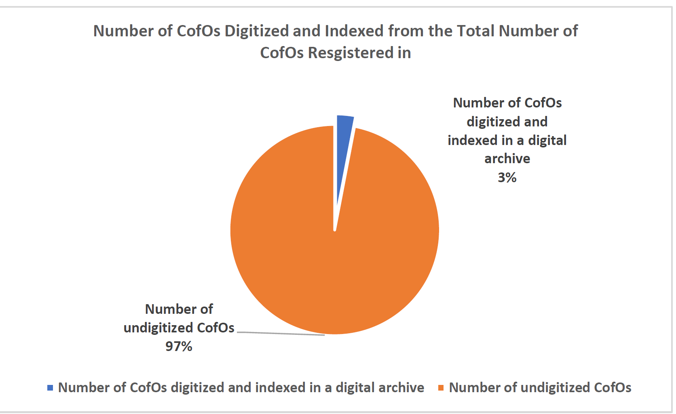

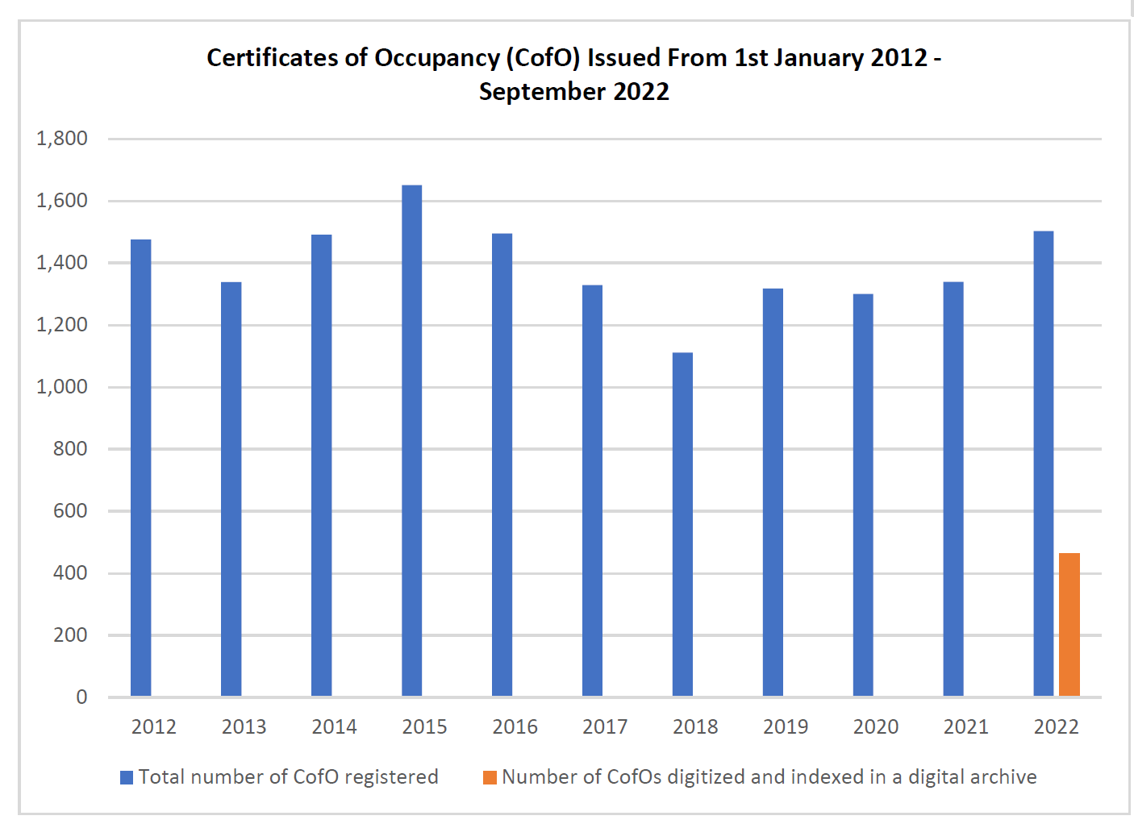

Ownership type | CofO issued (Jan 21-Dec 21) | CofO issued (Jan 22- Sept 22)
Male owned | 665 | 643
Female owned | 261 | 332
Joint owned | 383 | 456
Organizations/Corporate Bodies | 31 | 72
Total | 1340 | 1503

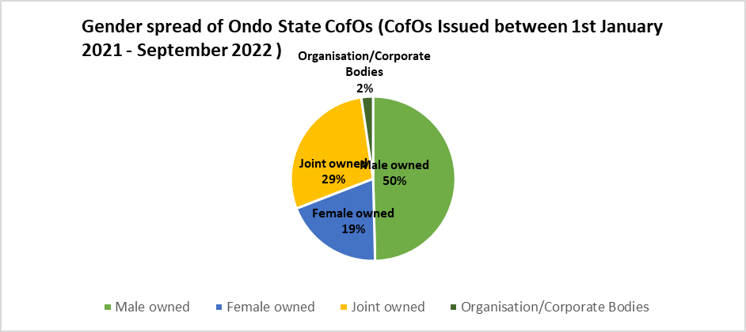

SIGNED:
PERMANENT SECRETARY
ONDO STATE MINISTRY OF LANDS AND HOUSING
14TH NOVEMBER 2022

